**SQL Statements**

1. Given three relations- sailors, boats and reserves. Sid, Bid and (Sid, Bid) are the primary keys of sailors, boats and reserves respectively. Sid and Bid are also the foreign keys of reserves which references Sid and Bid of sailors and boats relation respectively. No two sailors have same rating.

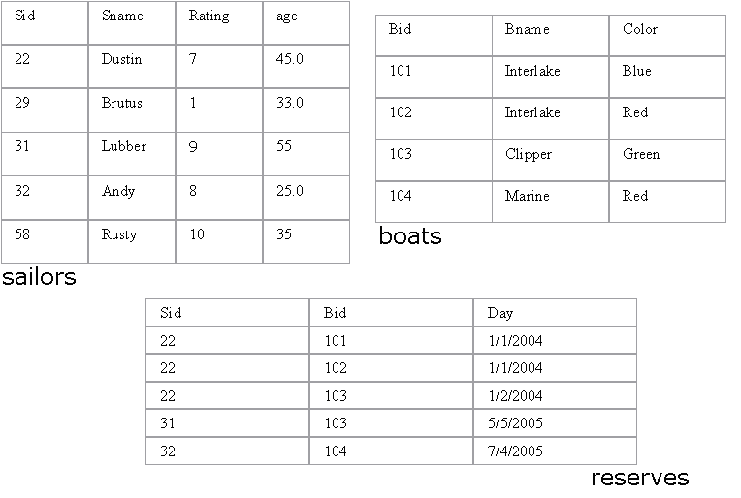

1. Find the names of sailors who have reserved a red boat.

**Query:** SELECT S.SNAME FROM sailors S,boats B,reserves R WHERE S.sid=R.sid AND R.bid=B.bid AND B.COLOR='RED';

1. Find the names of the Sailors who have reserved at least one boat.

**Query**: SELECT S.sname from sailors S, reserves R where S.sid=R.sid;

1. Compute increments for the ratings of persons who have sailed two different boats on the same day.

**Query:** SELECT S.sname, S.rating+1 AS rating FROM Sailors S, Reserves R1, Reserves R2 WHERE S.sid = R1.sid AND S.sid = R2.sid AND R1.day = R2.day AND R1.bid <> R2.bid

4. Find the ages of sailors whose name begins and ends with B and has at least 3 characters.

**Query:** SELECT S.age FROM sailors S WHERE S.sname LIKE 'B%B';

5.Find the names of sailors who have reserved a red and a green boat.

**Query:** select sname from sailors where sid in (select sid from reserves where bid in (select bid from boats where color = "red" or color = "green"));

6. Find the sids of all sailors who have reserved red boats but not green boats.

**Query:** select sname from sailors where sid in (select sid from reserves where bid in (select bid from boats where color = "red" or color != "green"));

7. Find the sailors with the highest rating

**Query:** select sname from sailors where rating = (select max(rating) from sailors);

8. Find the name of the oldest sailor.

**Query:** select sname from sailors where age = (select max(age) from sailors);

9. Count the number of different sailor names.

**Query:** SELECT COUNT( DISTINCT S.sname ) FROM Sailors S;

10. Find the no. of sailors who is eligible to vote for each rating level.

**Query:** Select count(*) from sailors s where age>18 group by rating;

11. Find the no. of sailors who is eligible to vote for each rating level with at least

two such sailors.

12. Find the sid of the sailors who have sailed exactly one boat.

**Query:** select sid from reserves group by sid having count(sid) = 1;

13. Find sailors who have not reserved any boats.

**Query**:

select sid from sailors where sid not in(select sid from reserves group by sid having count(sid) >= 1);

14. Find the Sailors who have reserved all the boats.

**Query:** select sid from reserves group by bid having count(bid) > (select count(bid) from boats);

15. Find all the sailors older than Dustin.

**Query:** select s.sname from sailors s where s.age > (select s1.age from sailors s1 where s1.sname ="Dustin");

16. Find all sailors whose ratings is greater than any others rating without using aggregates like MAX.

**Query:** select sname from sailors order by rating desc limit 0, 1;

17. Find the sailors with 3rd highest ratings.

**Query:** select sname from sailors order by rating desc limit 2, 1;

18. Find sids of the sailors who have reserved all the boats reserved by the sailor with sid =’31’.

**Query:** select sid from reserves where bid = (select bid from reserves where sid = 31);

19. List out all the sailors. For the sailors who have reserved some boats list out the boat’s bids also.

**Query:** select s.sid, s.sname, r.bid from sailors s join reserves r on s.sid = r.sid;

20. Assume that we have a table called customer.

|  |  |  |
| --- | --- | --- |
| CustID | Name | ReferredBy |
| 1 | Neeta Sayam |  |
| 2 | Dolly Dilly | 1 |
| 3 | Meena Kimi | 2 |

**Query:**

21. Find the names of all customers who are referred by others.

22. Find the names of all customers who have referred others.

23. Find the last three customer records inserted. (Refer the above Customer table)

**Query:** select * from customer order by custid limit 0, 3;

1. Given a table ‘customer’.

|  |  |  |
| --- | --- | --- |
| CustID | Name | Age |
| 1 | Neeta Sayam | 32 |
| 2 | Dolly Dilly | 23 |
| 3 | Meena Kimi | 43 |

How will you get rows between the range x and y where x and y will be entered by the user?

**Query:** select * from customer where custid between 2 and 5;

1. Given three tables- sailors, boats and reserves. Sid, Bid and (Sid, Bid) are the primary keys of sailors, boats and reserves respectively. Sid and Bid are also the foreign keys of reserves which references Sid and Bid of sailors and boats relation respectively. No two sailors have same rating. The sname and bname of the sailors and boats table are cannot be null.

